FOR IMMEDIATE RELEASE

Contact: Lieve Maas
lieve@BrightLightGraphics.com
Phone: +1 503.501.6031

From Manuscript to Published Book.
Seven Straightforward Steps to Self-Publishing

BEND, OR —September 30, 2022

Move from chaos to confidence.
Dream of self-publishing your book but have no idea where to start?

From Manuscript to Published Book is a straightforward guide for aspiring authors navigating the increasingly complex world of self-publishing.

In a workbook-style format, award-winning designer Lieve Maas serves up insights and tips gathered from her decades of experience in book design and self-publishing. From Manuscript to Published Book will show you how to:

- Break down the production, publication and distribution of your book into manageable tasks
- Outline a self-publishing plan that actually works
- Create an extraordinary reading experience for your audience

Quote:

“I am a teacher at heart and also very practical. When I get the same questions over and over again about how to self-publish a book, I want to help people understand the process by educating them so they know what they are doing. My book does just that.” –Lieve Maas
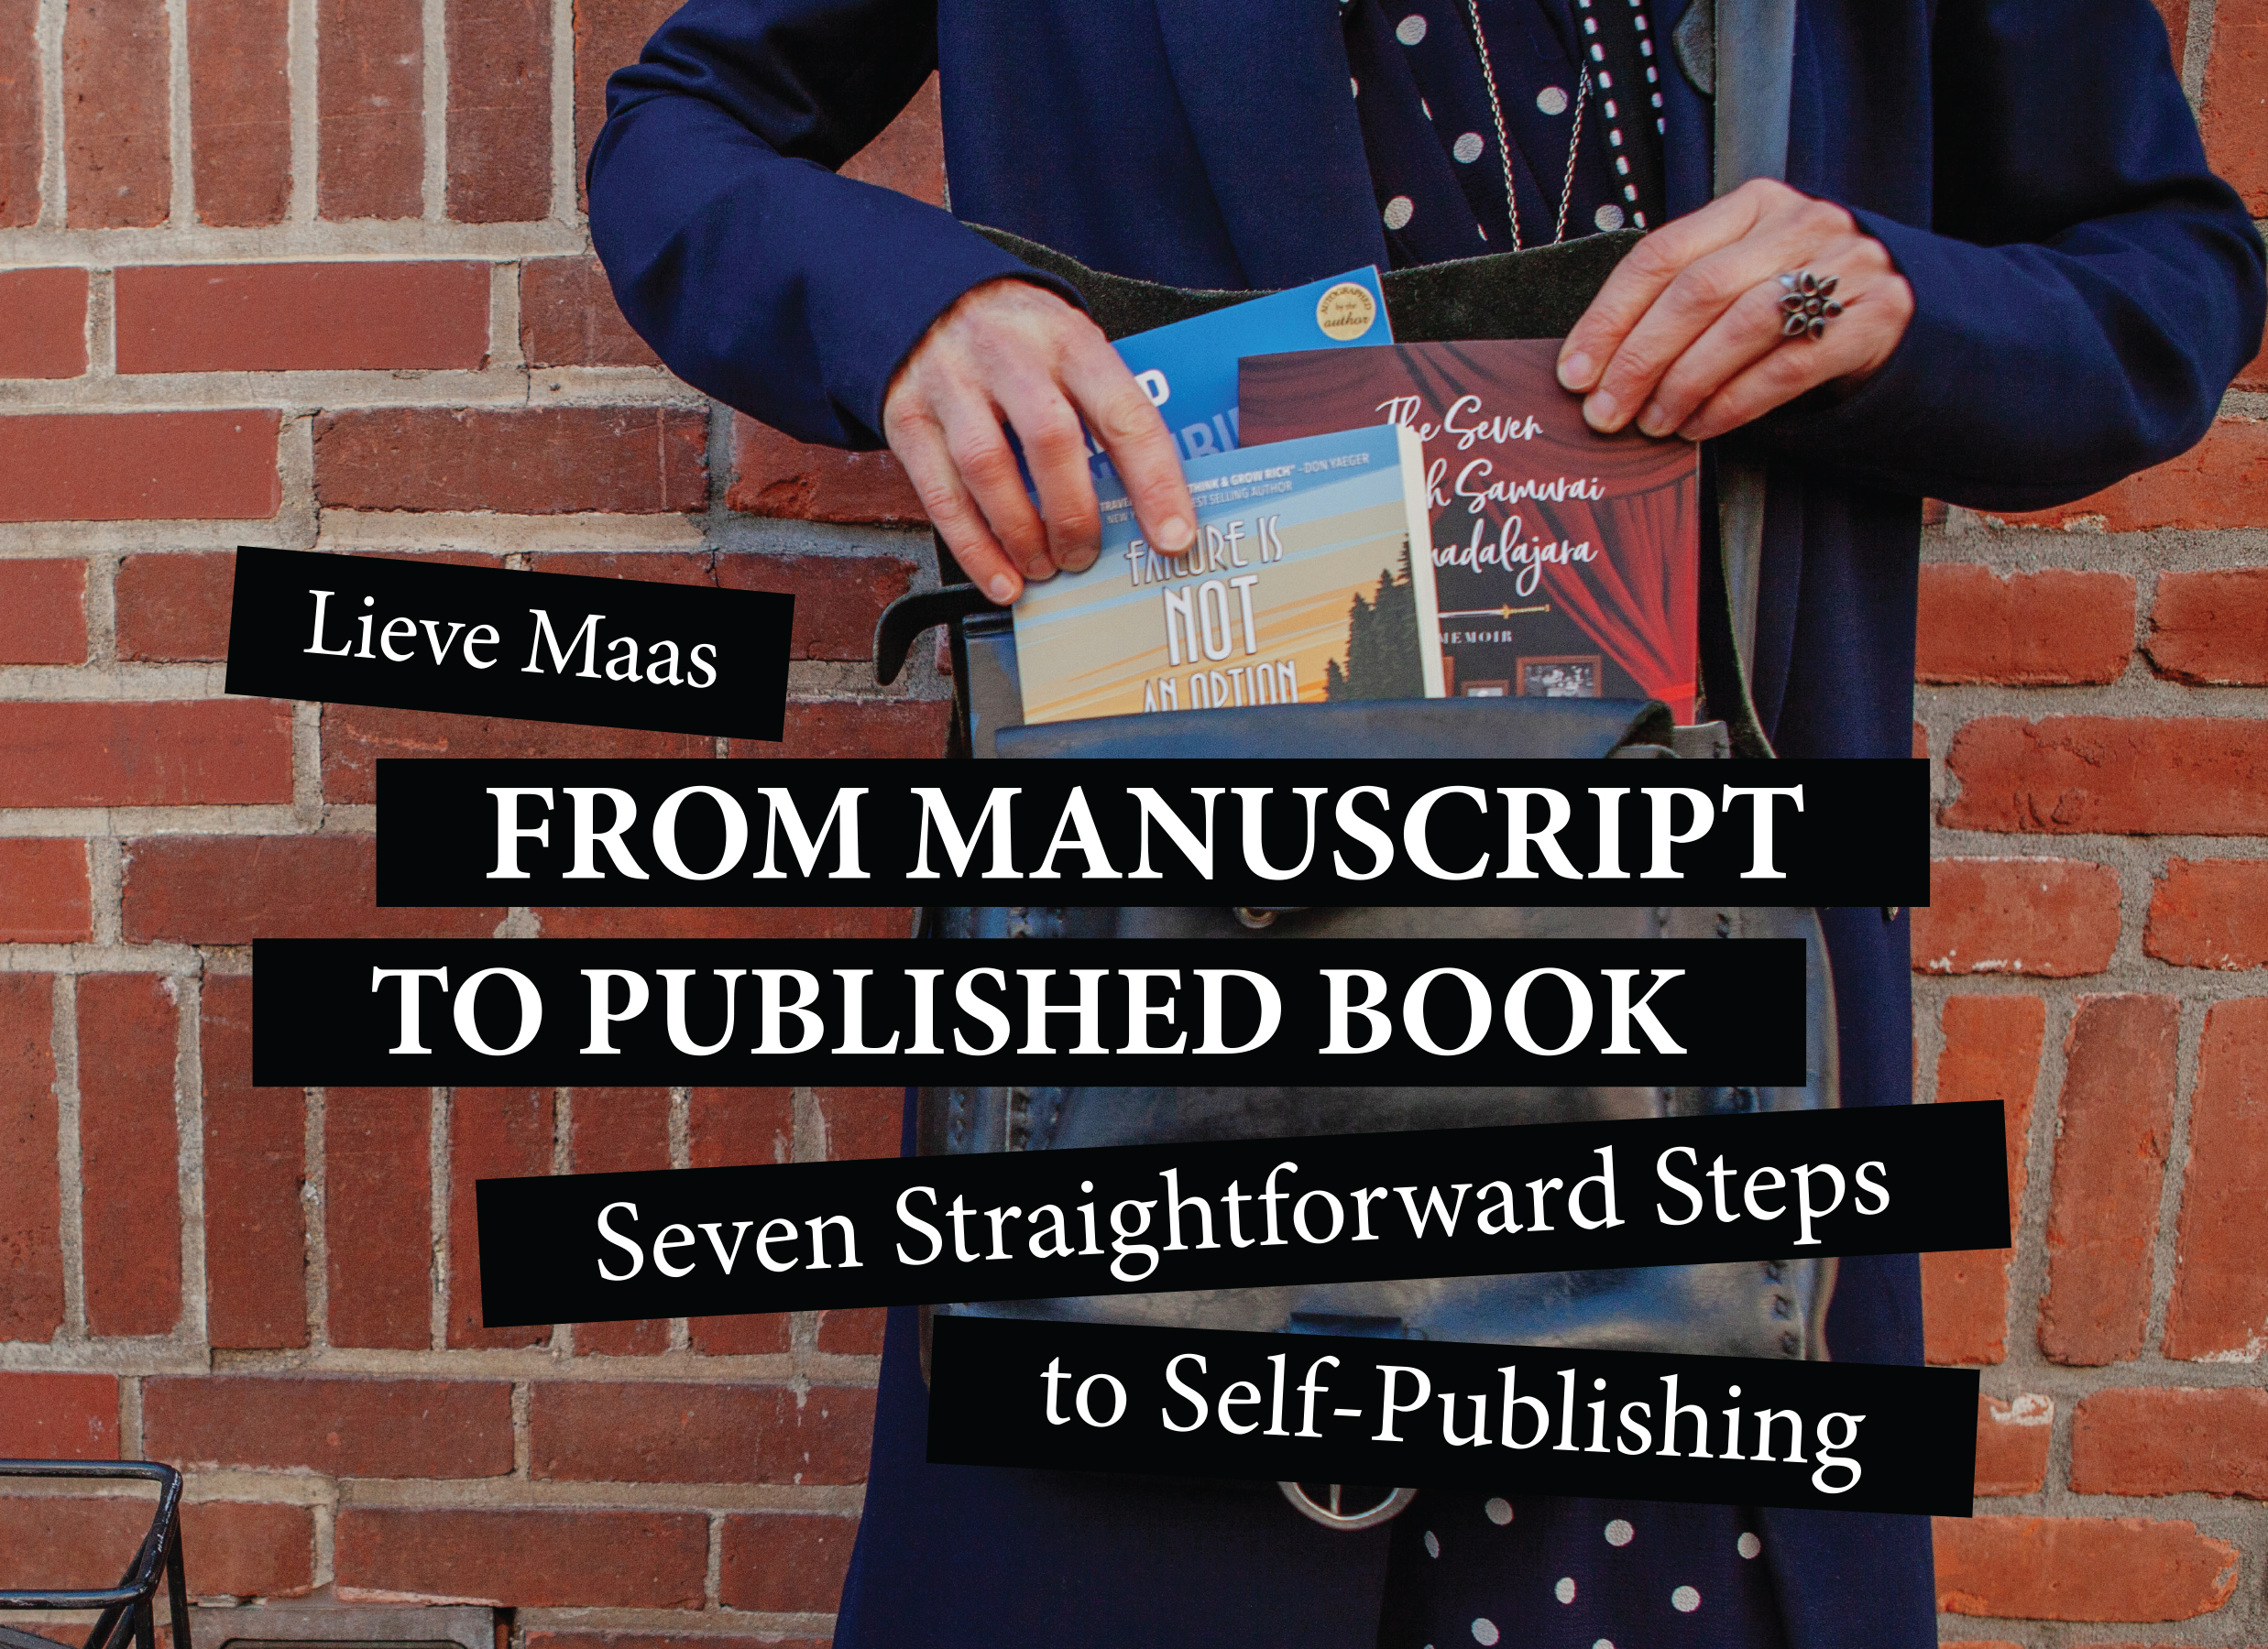

Author Q&A

Why did you write this book?
I wrote this book to fulfill several needs. First of all, I kept hearing the same questions repeatedly from my clients, who are all self-publishing authors. The question: “I have written my manuscript, now what?”, inspired me to create a practical, straightforward guide. The book incidentally also helps me better help my clients. When my clients take all the steps in this workbook, they gather the needed information along the way. That information is required to be able to publish their book. Since I had to keep asking for this info, I decided to standardize the process and create a book with steps that let an author gather what’s needed.

Whom is your book for?
Writers who want to become self-published authors. These could be business owners who wish to create a book as a marketing tool. Authors who want to make a legacy piece by writing their memoirs. Poets. Counselors and coaches who want to create a book to help their practice… There’s a wide variety of reasons why people seek to write and publish a book. They all have in common that they need insight into self-publishing and have limited time to re-invent the wheel.

How does one use your book?
This is a workbook consisting of seven action steps. Each step asks the reader to gather information and assets used during the actual process of self-publishing their work.

About the Author
Lieve Maas is a designer, brand strategist and self-publishing coach on a mission to support new authors as they launch their books into the world. Born and raised in the Netherlands, her relentless curiosity about art, design and visual storytelling led to degrees from both the prestigious Royal Academy of Fine Arts of Antwerp, and the University of Amsterdam.

An award-winning creative entrepreneur, Lieve has over two decades of experience in branding and book design and is the founder of Bright Light Graphics, a design firm in Bend, Oregon. Her newest workbook From Manuscript to Published Book dives into the nuts and bolts of self-publishing and helps aspiring authors move forward with confidence.

Endorsement
“Lieve's book is straightforward, easy to follow, and covers all the bases in the process of self-publication. It perfectly outlines the step-by-step procedure for presenting a beautiful and well-made book, simplifies the confusing details of "metadata" and "algorithms," and walks the author through the process of publication so they can get on to writing their next book.” –Mike Cooper

Book Information
From Manuscript to Published Book. Seven Straightforward Steps to Self-Publishing ($19.95, ISBN: 979-8985522105) is available at Amazon.

Review Copy Request
Working media can request a review copy of From Manuscript to Published Book. Seven Straightforward Steps to Self-Publishing. Send an email to lieve@BrightLightGraphics.com

Media Inquiries
Send an email to lieve@BrightLightGraphics.com

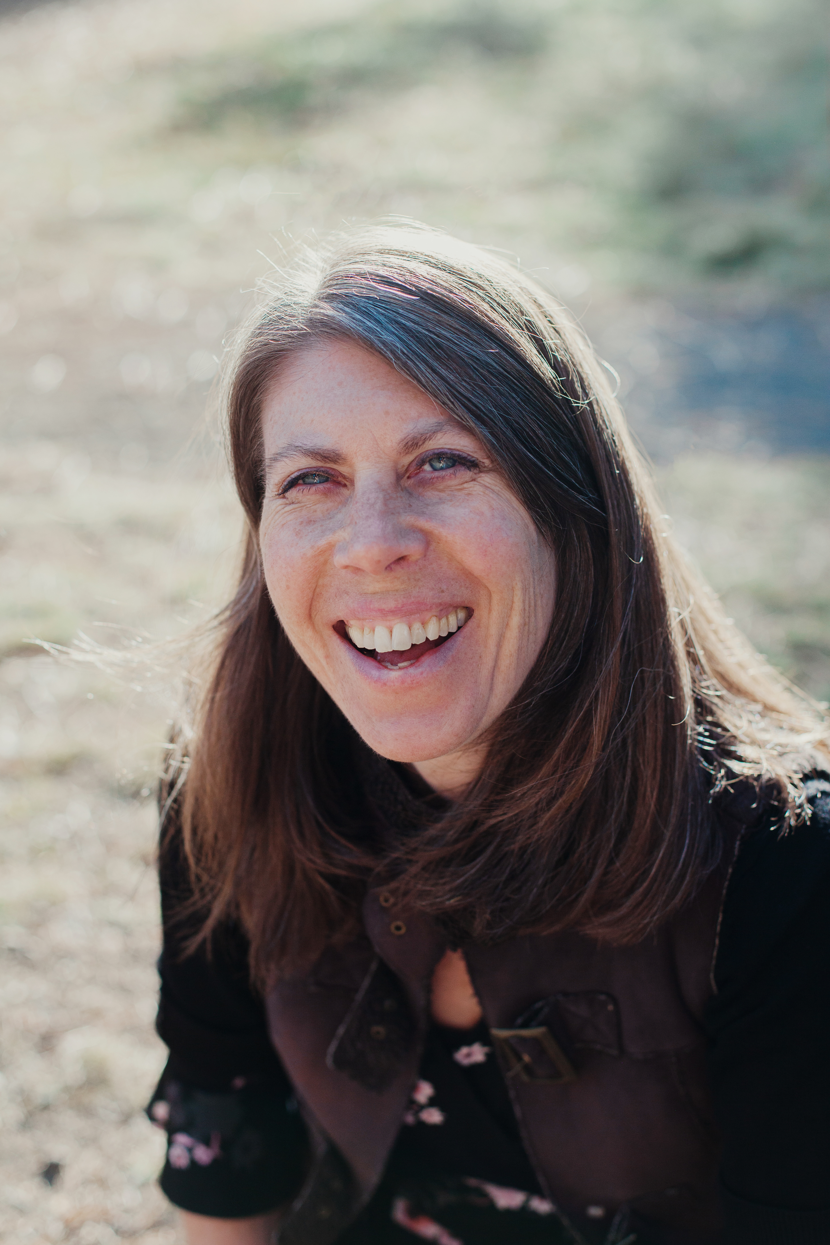
Photo of the author, Lieve Maas

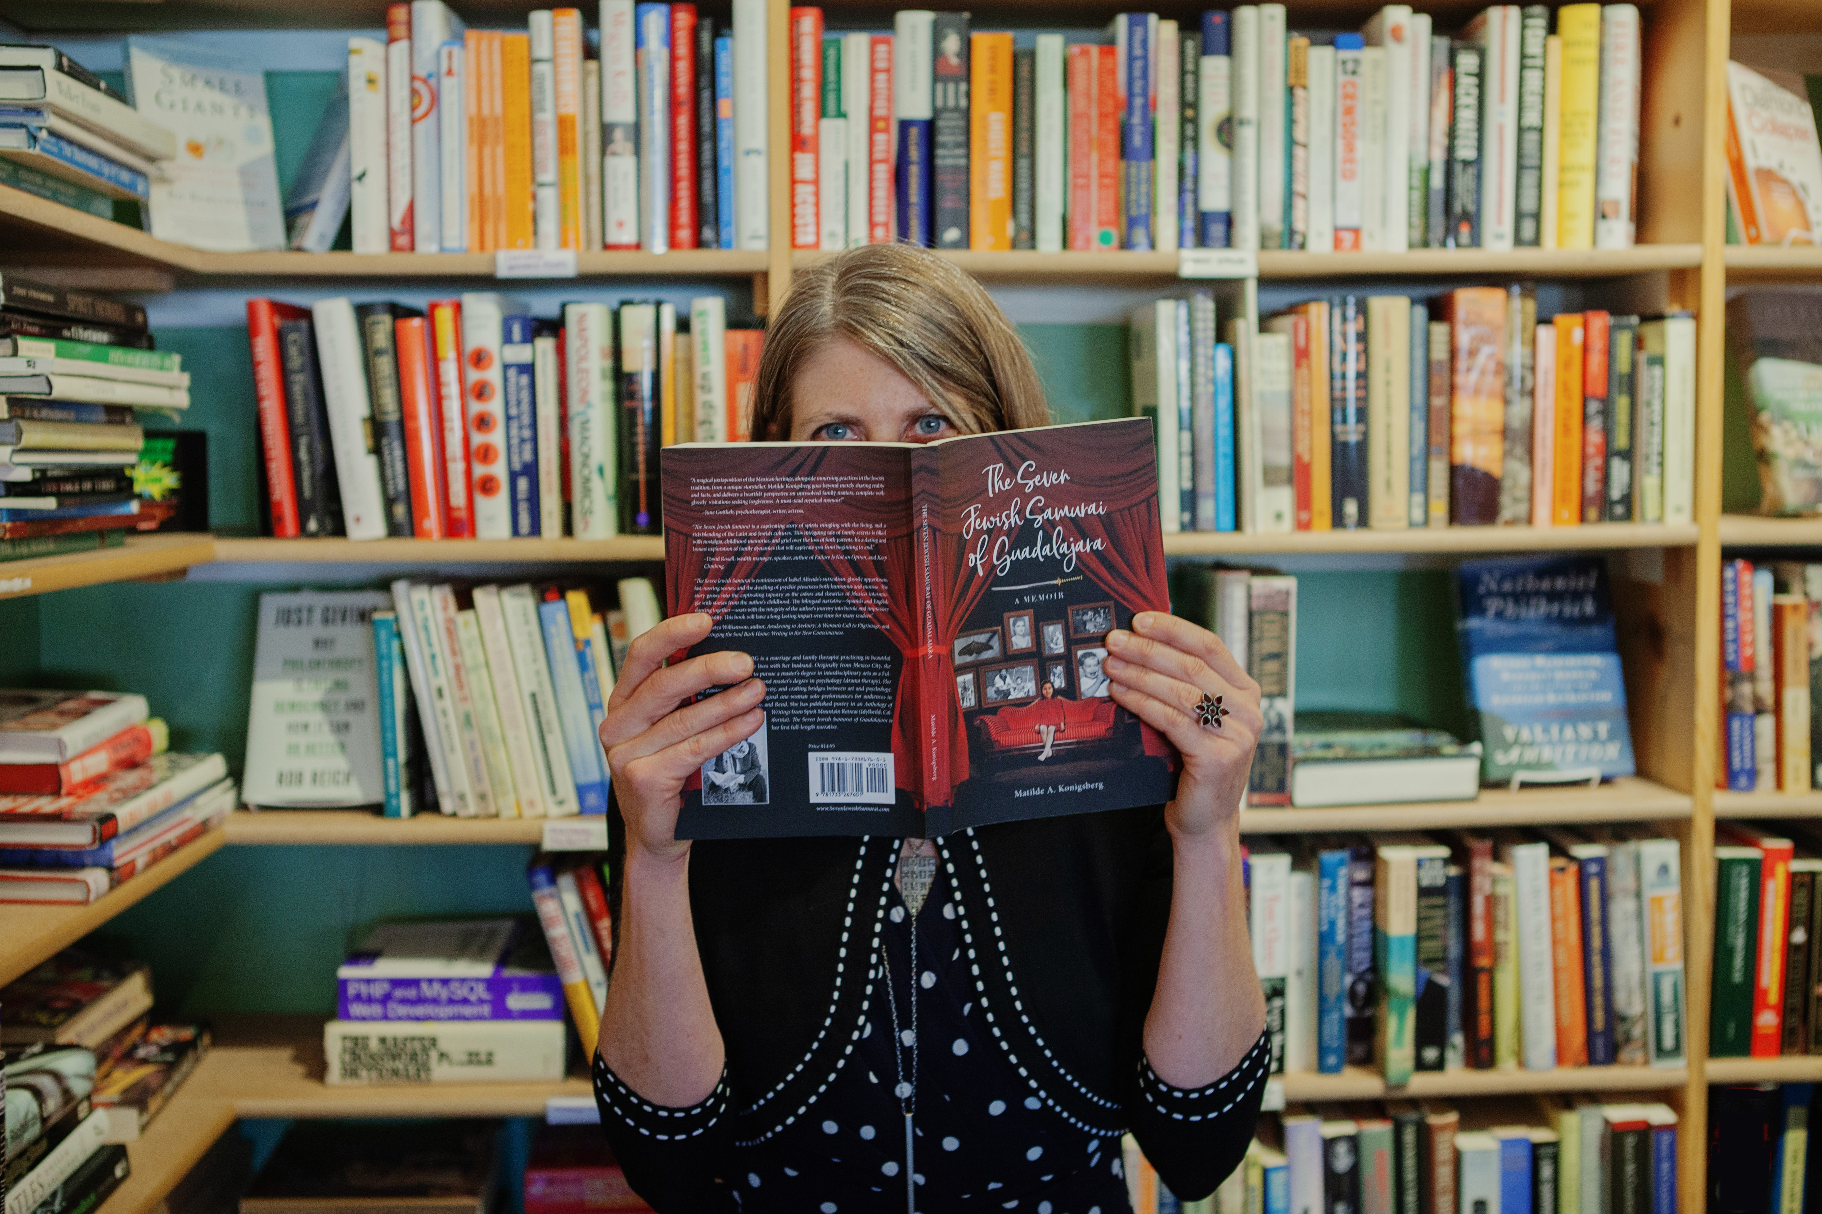
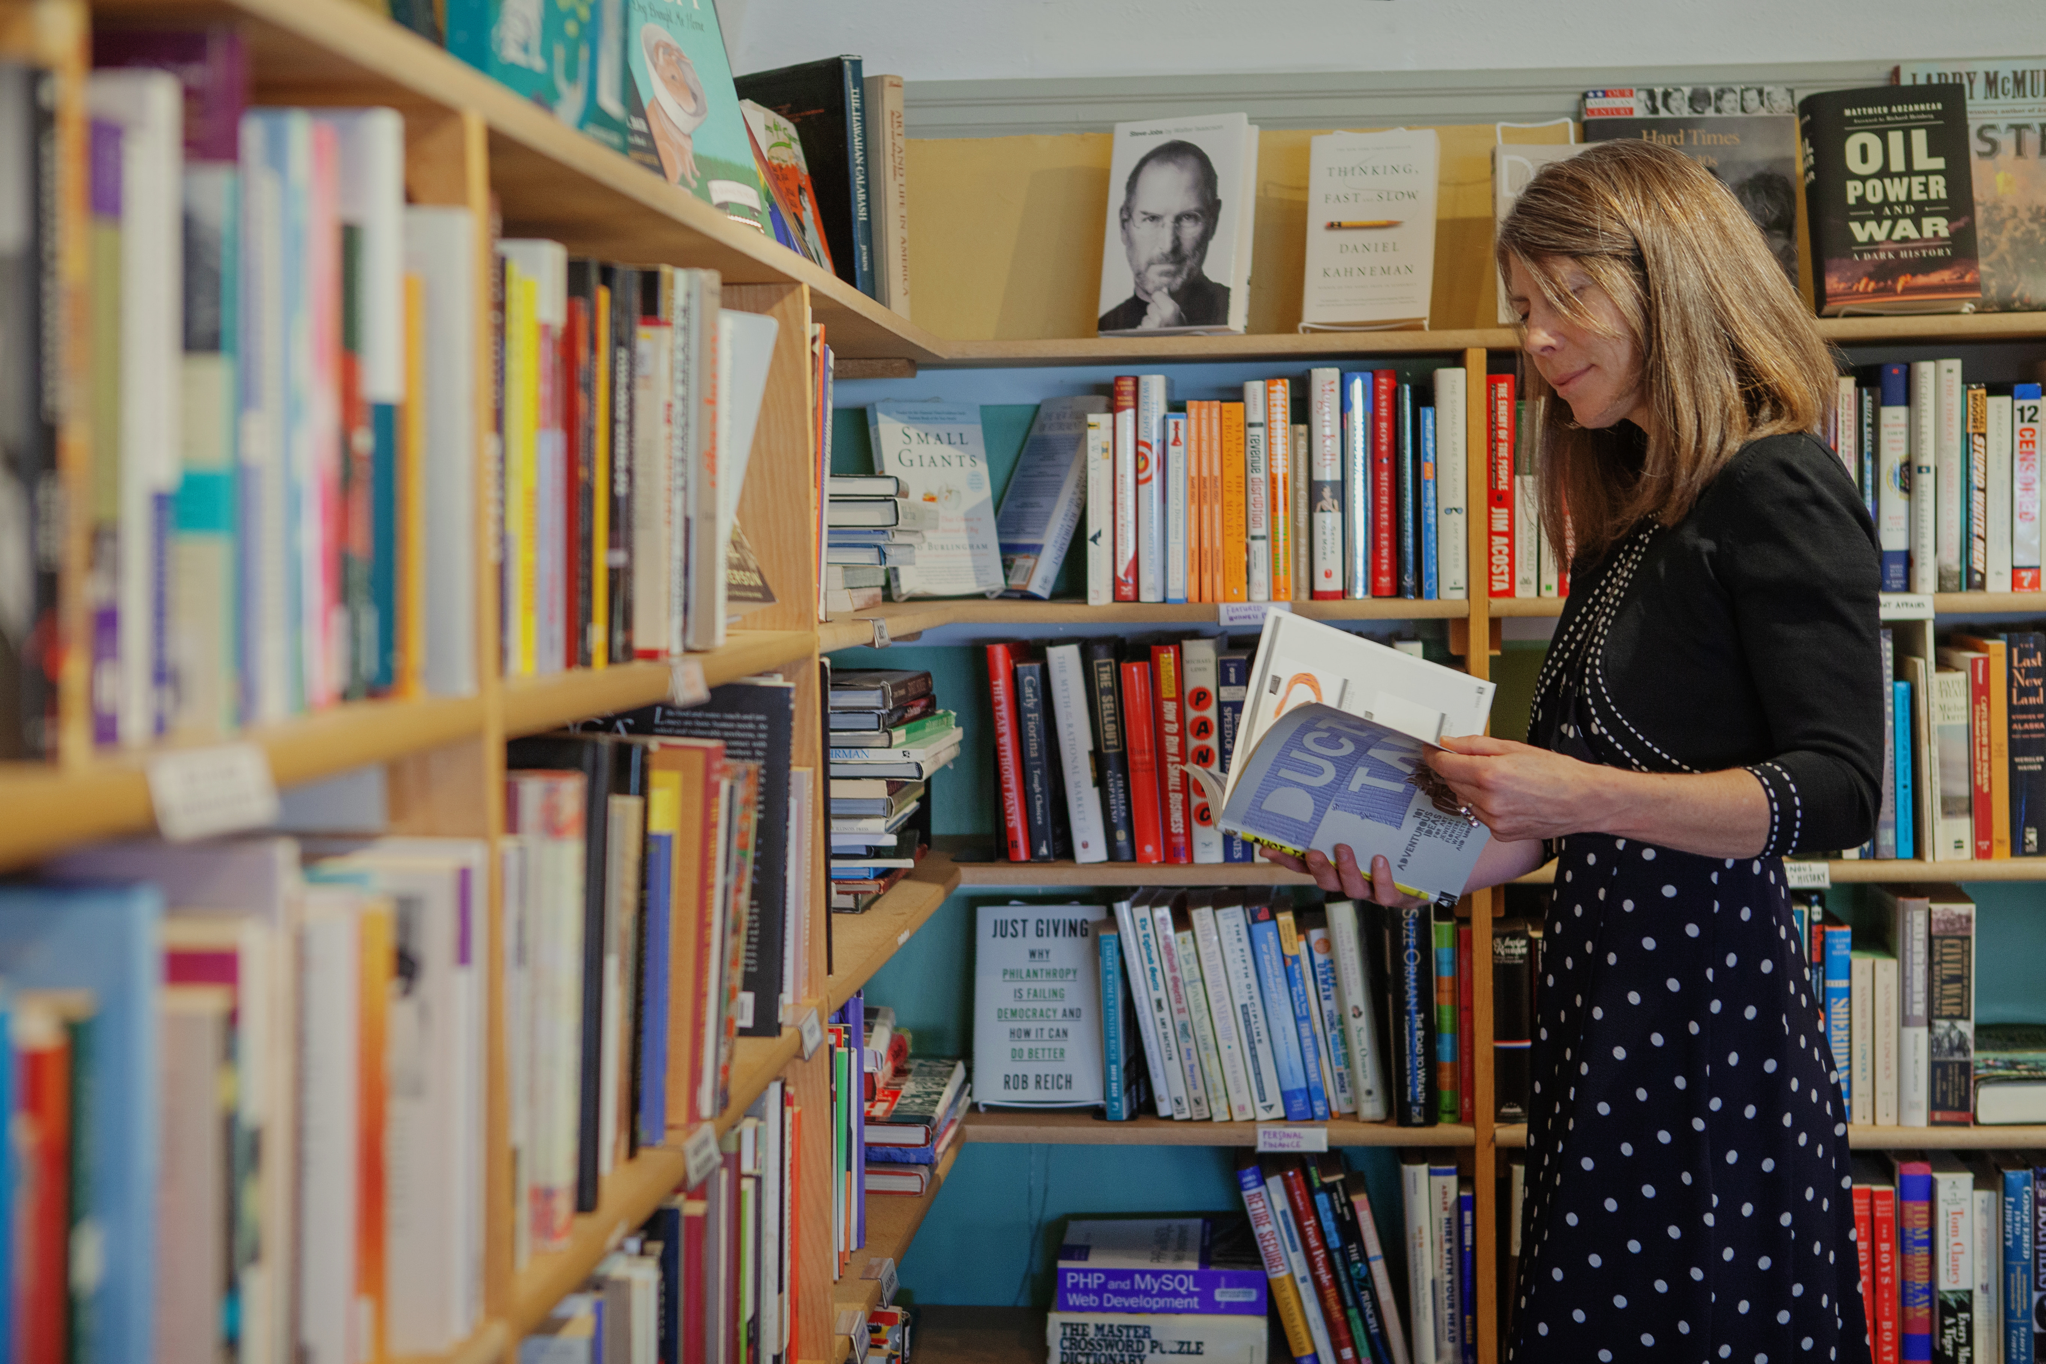
Photos of the author, Lieve Maas, at Dudley’s Bookshop Café, Bend, OR.

